Funding your LoT
For any Library of Things, finding funding and partnerships will play a huge part in the success of the enterprise.
How much does it cost to run a Library of Things?
Well of course it depends. As you establish your LoT it is important to consider what setup would work best for your community and, build your financial model on this. This will likely dictate the type of premises you go for, the location, etc. and therefore have implications on the costs.
Even with an army of volunteers giving their time for free, Letchworth Garden Shed still has significant costs, mainly premises (rent), utilities, insurance, shop staff, and tech (Lend Engine, Website, payment systems) etc.
So, we can’t give you a figure on how much it will cost to run your Library of Things, but what we can offer is some top tips.
- Use the Charity Commission website to be nosey. Have a look at a model of LoT you think would suit your community and look at their accounts. If they’re not a registered charity, they might have an impact report that includes a run-down of their finances - there are links to the ones we looked at in the chart below. They won’t tell you everything, but they do offer some insight into the different costs associated with running a LoT.
- Ask – find a model you like and reach out to an organisation that has done it, and ask if they would be happy to share some insight into how much it costs them to run their LoT (if you can, go visit and buy them a cup of tea first). We are all in the business of sharing so you will be pleasantly surprised how willing they will be to help.
- Consider the different models of running your LoT and build out different budgets to match these scenarios. For example, you could build a budget where you are fully volunteer- run, and one where you have staff. Each has pros and cons, but you will at least get a sense of what it looks like.
- Not sure where to start with budgeting and forecasting? These resources from the Charity Finance Group might help.
- Consider what support or stuff you can get for free (we’re putting together a list with the support we found but be mindful that sometimes this can take longer to secure or might not be exactly what you want.
- Find a finance person to help you out. Charterpath is set up to match you to finance skills if you can’t find someone locally. You might find it useful to split up the finances into day-to-day book-keeping - what’s going in, what’s coming out - and the big picture things like report-filing and forecasting.
As your organisation develops it is likely your needs and costs will change. You might want to open for more days, or you might find running purely on volunteers isn’t sustainable. Taking time to stop and review your plans and the finances is crucial to being successful.
Where can you expect to get money from to run your LoT?
One of the key considerations when starting an organisation is what type of structure you will take on. For example, will you go for Charity Incorporated Organisation or a Community Interest Company? We won’t go into lots of detail on this as many others have done it for us. This blog offers a helpful overview and of course the govs websites are full of guidance.
For example:
- Charity Commission
- Office of the Regulator of CICs
Why are we talking about structure when we are supposed to be discussing funding? Well, the structure you choose will impact how you’re allowed to make money.
NCVO produced a resource many years ago that outlines four types of charity income streams. These streams are also applicable to social enterprise structures like CICs. Keep in mind, an important consideration is that some funders only support charities.
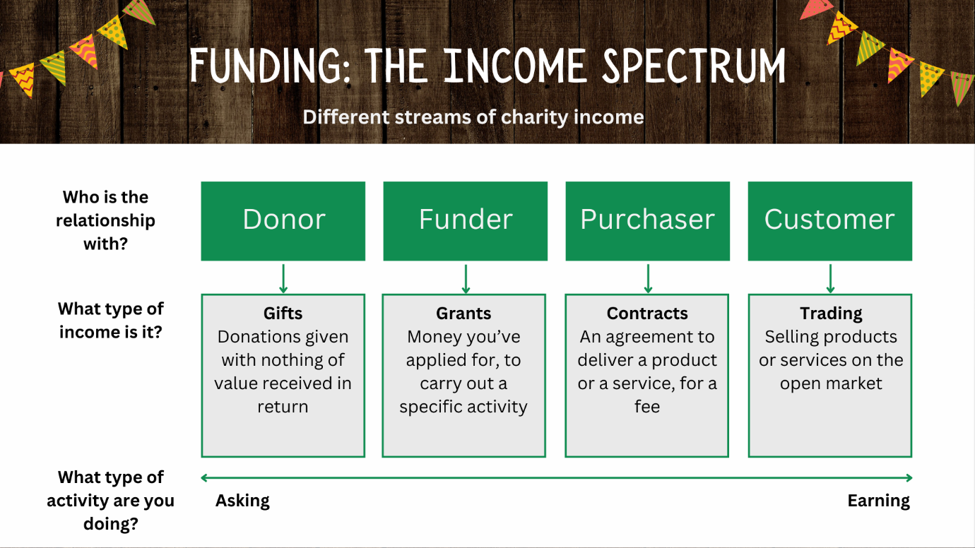
Image adapted from The Income Spectrum (NCVO 2016).
Income Spectrum resource from NCVO.
How is Letchworth Garden Shed Funded?
Here at Letchworth Garden Shed our income comes from three streams: gifts, grants and trading.
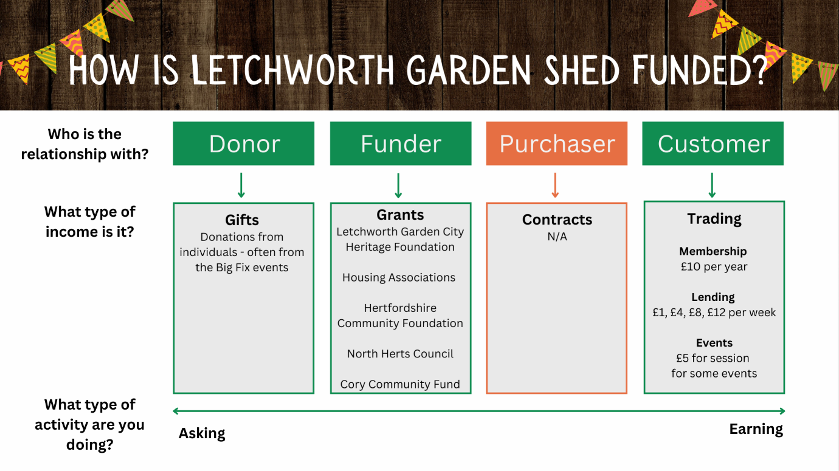

Where can I go to find grants?
- Charity Excellence Framework has a great funder finder.
- Environmental Funders network: EFN GFF: Funding Opportunities - Google Sheets.
- Your local Council for Voluntary services will often send funding opportunities through their newsletter. You can find your local one through NAVCA.
- Look at how others have been funded. Their accounts and website will show you who likes to fund LoTs.

